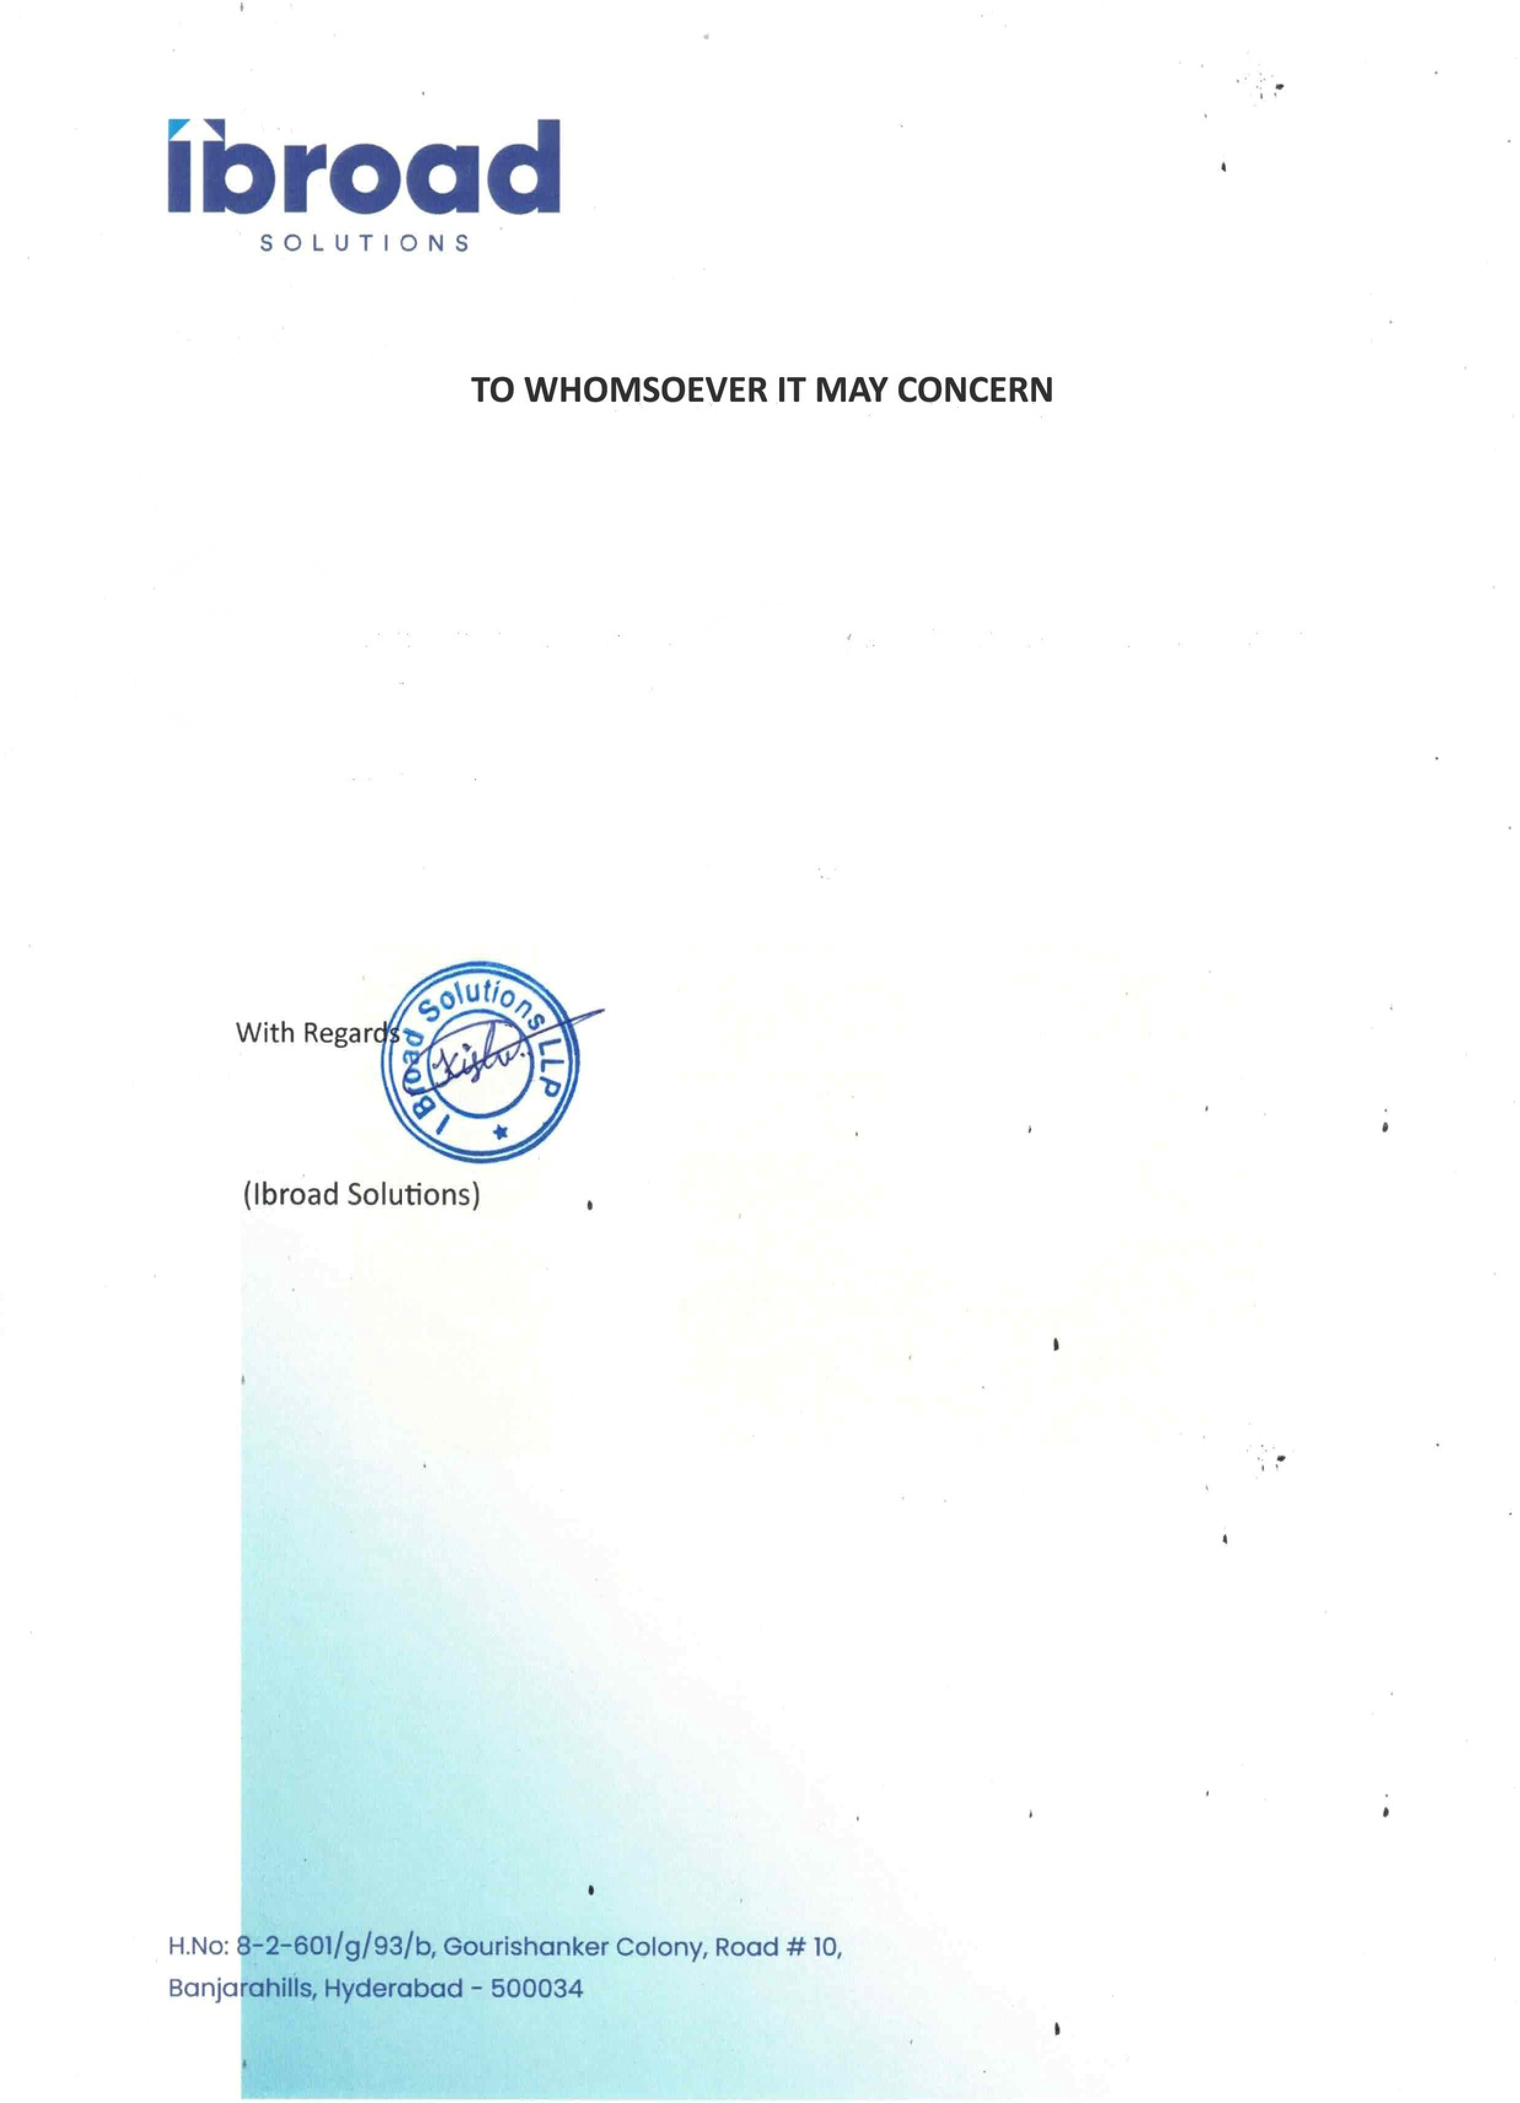

02

April

2025

This is to certify that Ms. Sileveru Jahnavi was working as an AI Software Engineering

Intern with Ibroad Solutions LLP from 17th-February-2025

She has been relieved from the employment effective 2nd-April-2025.

We wish her the very best in all his future endeavors.